**ANNOVA**

**Introduction:**

ANOVA is a statistical method that stands for analysis of variance.  ANOVA was developed by Ronald Fisher in 1918 and is the extension of the *t* and the *z* test.  Before the use of ANOVA, the *t*-test and *z-*test were commonly used.  But the problem with the T-test is that it cannot be applied for more than two groups ANNOVA is used to do the analysis of variance between and within the groups whenever the groups are more than two. ANOVA creates a way to test several null hypotheses at the same time.

The logic behind this procedure has to do with how much variance there is in the population.  It is likely the researcher will not know the actual variance in the population but they can estimate this by sampling and calculating the variance in the sample.  You compare the differences in the samples to see if they are the same or statistically different while still accounting for sampling error.

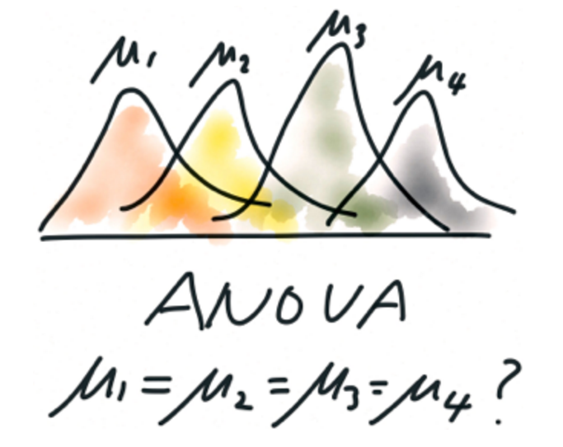

**Use of ANNOVA in different ways:**

Commonly, we can use ANOVA in three ways: [one-way ANOVA](http://www.statisticssolutions.com/data-analysis-plan-one-way-anova/), two-way ANOVA[,](http://www.statisticssolutions.com/academic-solutions/resources/directory-of-statistical-analyses/factorial-anova/) and N-way Multivariate ANOVA.

One-Way: When we compare more than two groups, based on one factor (independent variable), this is called one way ANOVA.  For example, it is used if a manufacturing company wants to compare the productivity of three or more employees based on working hours.  This is called one way ANOVA.

Two-Way: When a company wants to compare the employee productivity based on two factors (2 independent variables), then it said to be two way (Factorial) ANOVA.  For example, based on the working hours and working conditions, if a company wants to compare employee productivity, it can do that through two way ANOVA.  Two-way ANOVA’s can be used to see the effect of one of the factors after controlling for the other, or it can be used to see the INTERACTION between the two factors.  This is a great way to control for extraneous variables as you are able to add them to the design of the study.

N-Way: When the factor comparison is taken, then it said to be n-way ANOVA.  For example, in productivity measurement if a company takes all the factors for productivity measurement, then it is said to be n-way ANOVA.

**General procedure to calculate ANNOVA:**

In an ANOVA, first sets up the null and alternative hypothesis.

H0: The null hypothesis assumes that there is no significant difference between the groups.

H1: Alternative hypothesis assumes that there is a significant difference between the groups.

After cleaning the data, we must test the above assumptions and see if the data meets them.  They must then do the necessary calculation and calculate the F-ratio.  After this, we must compare the critical value of the F-ratio with the table value or simply look at the p value against the established alpha.  If the calculated critical value is greater than the table value, the null hypothesis will be rejected and the alternative hypothesis is accepted.  Rejecting the null hypothesis, we will conclude that the mean of the groups are not equal.  If the calculated value is less than the table value, we will accept the null hypothesis and reject the alternative hypothesis.  This will tell you that there is a difference in what you were testing, but does not tell you WHERE the difference is.  This is to say, if the we were testing several groups against one another, we would know that there is a difference between the means of the groups but not which individual groups are different

**Applications:**

ANOVA is used very commonly in business, medicine or in psychology research.

* In business, ANOVA can be used to compare the sales of different designs based on different factors.
* A psychology researcher can use ANOVA to compare the different attitude or behavior in people and whether or not they are the same depending on certain factors.
* In medical research, ANOVA is used to test the effectiveness of a drug.

**Additional information:**

Data level and assumption plays a very important role in ANOVA.  In ANOVA, the dependent variable can be continuous or on the interval scale.  Factor variables in ANOVA should be categorical.  Like the T-test, ANOVA is also a parametric test and has some assumptions, which should be met to get the desired results.  ANOVA assumes that the distribution of data should be normally distributed.

ANOVA also assumes the assumption of homogeneity, which means that the variance between the groups should be equal. ANOVA also assumes that the cases are independent to each other or there should not be any pattern between the cases.  As usual, when planning any study, extraneous and confounding variables need to be considered.  ANOVA is a way to control these types of undesirable variables.

Interview Questions:

1. What is Analysis of Variance (ANOVA)?
2. What are the assumptions of ANNOVA?